**Name:** Luke Morgan

**Student number:** S3980747

**Student email address:** [s3980747@student.rmit.edu.au](mailto:s3980747@student.rmit.edu.au)

**About me**: I am 28, born and raised in Byron Bay, a hardcore gamer and very interested in cyber security. I have a mug collection and I like cute things.

**Education:** Certificate IV in cyber security Tafe QLD (2022)

High school Certificate (2012)

My interest in IT has been slowly growing since I was younger playing games on my home computer when I was around 12-13. When the pandemic first started affecting Australia, I lost my full-time job. I struggled to find a career path that I wanted to follow, then I stumbled into the job trainer program and jumped at the chance to study cyber security. Ever since starting my Certificate IV in cyber security. I have been very interested and seeking a career in Cyber security. Firsthand experience using various cyber security tools in assessments such as: Creating multiple virtual machines set up on one physical computer so I can simulate a man in the middle attack to grab unencrypted credentials with Wireshark, creating and preforming a red vs blue incident response team exercise. These hands on assessments really drove my hunger to continue to learn more about IT and cyber security. I have no formal IT work experience.

I chose RMIT as I found that the online model of learning suited me better than on campus. I enrolled through online university’s Australia and RMIT is the university that they do it through. RMIT is a highly regarded university when it comes to IT, so employers will look at a degree from RMIT favourably.

I expect to learn a range of aspects of IT: More in depth programming skills; better ways at communicating to co-workers/clients; Cyber security; Data science; Networking; Business Analytics and more!

**Ideal job**

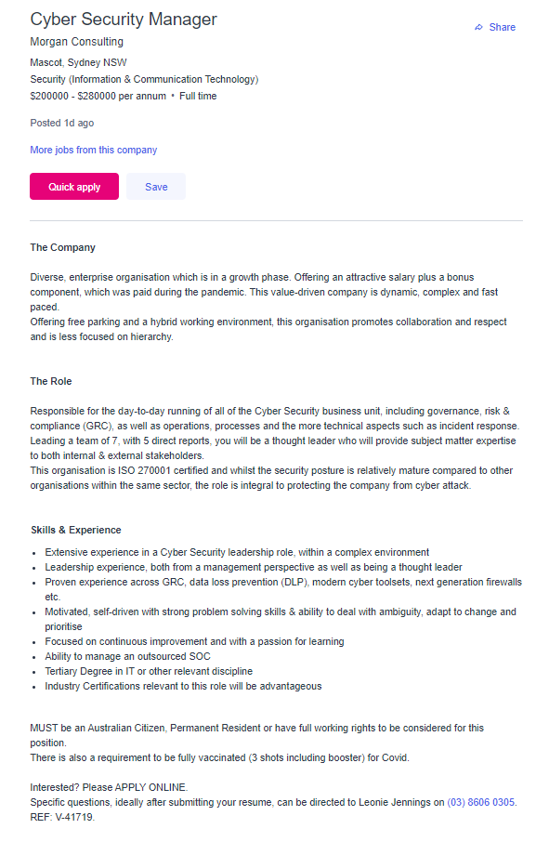

Link to job: <https://www.seek.com.au/job/58360980?cid=ios-share>

**Ideal Job cont.**

This position is at the top of the cyber security roles in this company. The role involves running the Cyber security business unit, incident response, GRC, leading and managing a response team. This position is appealing to me as I have thought of myself as a leader, is a senior cyber security position, and the pay is impressive.

This role requires: Previous experience in a cyber security management role such as CSOC manager; Experience in Governance, Risk and Compliance (GRC); Data Loss Prevention (DLP), cyber security toolsets and firewall configurations. Ability to manage a Cyber Security Operations Centre (CSOC) Must be Motivated, self-driven, focused on continuous improvement, have strong problem-solving skills and able to adapt to changes. Finally, this role also requires a tertiary degree in IT or related discipline and any industry certifications related to cyber security would be beneficial.

The experience, skills, and qualifications I currently have are as follows:

I have a certificate IV in cyber security (Tafe QLD 2022) as well as: leadership; mentoring; and managing experience; strong customer and client service skills; I am always looking to improve myself and gain new skills or knowledge especially when it comes to cyber security. My experience, skills, and qualifications and on the path towards what is required for the Cyber Security manager position but are not there yet. I still require experience in a Cyber Security leadership role, more experience in governance, risk and compliance and data loss prevention. I also require more training and knowledge in cyber security toolsets, processes, and firewalls. I do however already have an industry Certification related to cyber security.

The path I should follow to be a candidate for this position is:

Complete and attain the bachelor’s degree in information technology from RMIT.

Complete and attain the master’s degree in cyber security.

Once I have my Bachelor’s/master’s degree, I can search for a job in a cyber security operation centre (CSOC) as an analyst and gain some hands-on experience. While working as a CSOC analyst or similar I will work towards industry certifications such as the CISSP certification.

After working as a CSOC analyst or similar for a few years, I will find a new role higher up as a manager of a CSOC or similar. After working as a manager of a CSOC or similar I should have the required experience and skills to be a candidate for the Cyber security Manager position.

**Personality Profile**

Result of an online Myers-Briggs test: ISFJ-T (Defender)

Result of an online learning style test: Visual learner 50%/ tactile learner 30%/ Auditory 20%

Result of big 5 online personality test: Openness to experience – Medium characteristic

Extraversion – Low Characteristic

Conscientiousness – Medium Characteristic

Agreeableness –High Characteristic

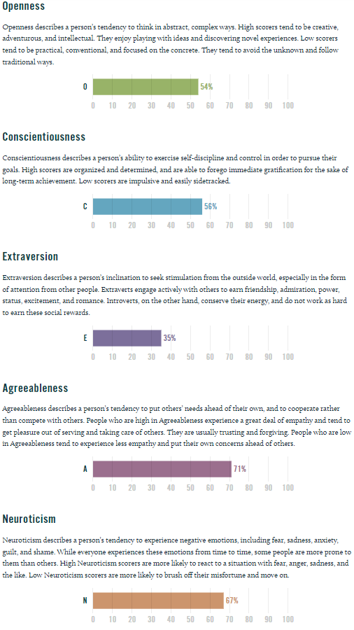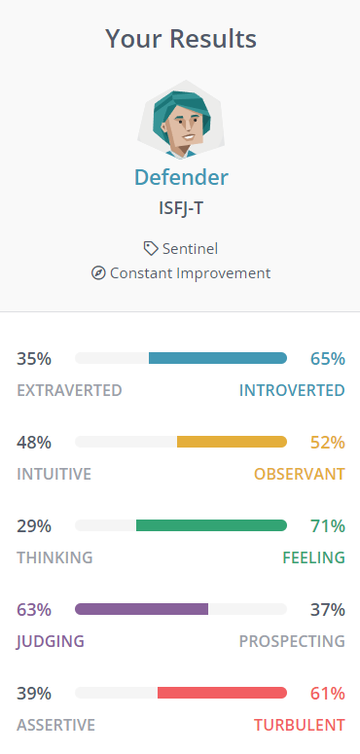 Neuroticism – Medium Characteristic

The above online test results seem to be very accurate.

I believe myself to be an ISFJ-T(Defender) and Visual learner, Somewhat open to new experiences, very conscientious, a little extravert but mostly introvert, very agreeable and have a tendency to feel negative emotions . As an ISFJ-T I am Hardworking and devoted, with a strong sense of responsibility. I Provide care and support of my friends and family, with a strong eye for detail. I have always through I was a visual learner, but I also learn well with hands on experience. I Generally like to stay with in my comfort zone, though I do like to try new things sometimes, as an extravert, I can gain energy from being social, but also from being alone. It really depends on what the social event is and on the other hand going for a walk alone with some music is great. I feel that I have good control over my emotions in most situations.

The results of these tests show that in a team I can be counted to meet deadlines, will work well in a team due to my well-developed people skills, and that I probably will not seek recognition of the effort I put in. I should be able to keep cool and work well under pressure and time restraints, attending meetings will most likely cause some level of anxiety and use a lot of energy.

When forming a team, I should look for others like me; people that are aware of the deadlines. People in the team should understand each other’s boundaries and limits to not over stimulate or reduce each other’s energy. Having a more collaboratory group where we all work together instead of competing. Though there should be one designated leader as all groups should. This will provide me with the best possible group environment so we can all produce the best project we can.

<https://my-personality-test.com/personality-type-indicator>

<http://www.educationplanner.org/students/self-assessments/learning-styles-quiz.shtml>

<https://www.16personalities.com/isfj-personality>

**Project Idea**

**Overview**

My project idea is a company that performs companywide penetration testing but specialling in Physical/Environmental and internal threats. There is: physical/Environmental; web; network; internal; external; social engineering; white; grey; and black box penetration testing.

What makes my idea different is that not only is it a combination of: physical/Environmental; internal; social engineering and internal network security. We proceed under the black box penetration testing guise. Once a client has paid for our services, we us an “accomplice” that will be aiding our testing from the inside. Just like if there was a real internal threat. Not only that. Depending on the scope of our service (we recommend a 1-year service). We will plan with our contact, but no one else in the business will know a thing to generate the most authentic response. Our focus is the physical/Environmental and the internal threats, as these are often overlooked. With a yearlong approach, all previous breach attempts and knowledge gained from them are combined into 1 final attack where we use all that we have learnt about the business to conduct a companywide breach.

**Motivation**

I am motivated to create this project as I am very interested in cyber security and penetration testing. Creating the documentation and processes will be interesting. If the project is successful, it may become my business or a business model I will adapt in a business I may create in the future. As Physical/Environmental, internal, and social engineering security is often overlooked, having a business’s focus around those weaker points will fill a gap in the market and overall strengthen the visibility of those exploits and vulnerabilities.

**Description**

The project is a business model that performs companywide penetration testing but specialling in Physical/Environmental and internal threats. So that means, that a client will receive web; network; internal; external; white; grey; and black box penetration testing but will have their physical/environmental and internal security scrutinised. The way we test internal threat protection is by using an “accomplice”. The “accomplice” is a current employee that receives a paid incentive to preform actions on our behalf. We first start will a small task, such as find a window that can open, and will increase the threat of the action (We will never ask the accomplice to damage or remove anything that will harm the business in any way and will only use photo evidence when presenting findings). The accomplice may also aid us in leaving security doors open for our technicians to gain access, this is where the need for the combination of physical and internal security becomes apparent.

If our operation scope is as we recommend (1 year service, and all areas of penetration testing). We will plan at least 1 attack a month minimum, where we attempt to gain access to any valuable resources, gain entry to restricted areas, gain access to the internal network, use our accomplice to aid us in the breach though most likely we will use a combination of them to have the most effect. After each attempt, we list areas that were vulnerable or areas we were able to breach or where the accomplice had access. If these vulnerabilities are with in the acceptable level indicated in the scope, they will only be recorded and used later by our team. If the vulnerabilities are outside of acceptable levels, they will be immediately reported to the company and not used for farther testing.

**Tools and Technologies**

Our company uses social engineering through social media and other publicly accessible websites. Depending on how the complexity of the client company’s security, we may use the following to attempt a breach: public physical access, using stolen credentials at check points or to gain access to secure locations or resources, using social engineering to try pass as employees or third parties to gain access. We may also use RFID badge/ID card signal duplicators to trick sensors to gain access. We will need to have our go bags ready with a laptop running windows/Kali Linux tooled up to collect any unencrypted credentials or to access the network physically or via wireless; port sniffing; vulnerability scanning; website spidering etc.

**Skills required**

Business skills and knowledge, client management and communication skills, network knowledge and skills, Strong social engineering skills. Our technicians will also need to have some physical capability as they may need to climb fences or squeeze in tight spaces. Also, all penetration testing skills (physical, environmental, web, network, internal, external, social engineering).

**Outcome**

The expected outcome from this project is to see if this business model would be viable, if it would be able to penetrate the market and be lucrative. If